ASSIGNMENT -2
1. CREATE THREE INSTANCES, INSTALL NGNIX AND APPLY APPLICATION LOAD BALANCER(ALB)
BEFORE CREATING INSTANCES, FIRST CREATE SECURITY GROUP
1. CREATE SECURITY GROUP
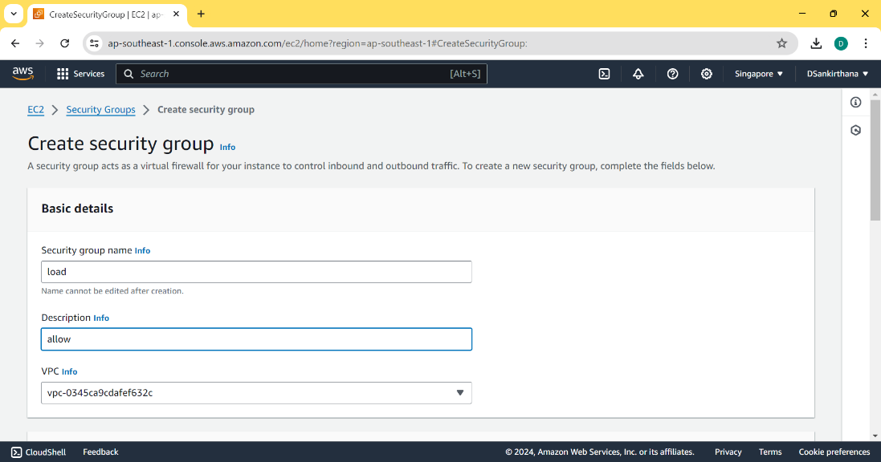
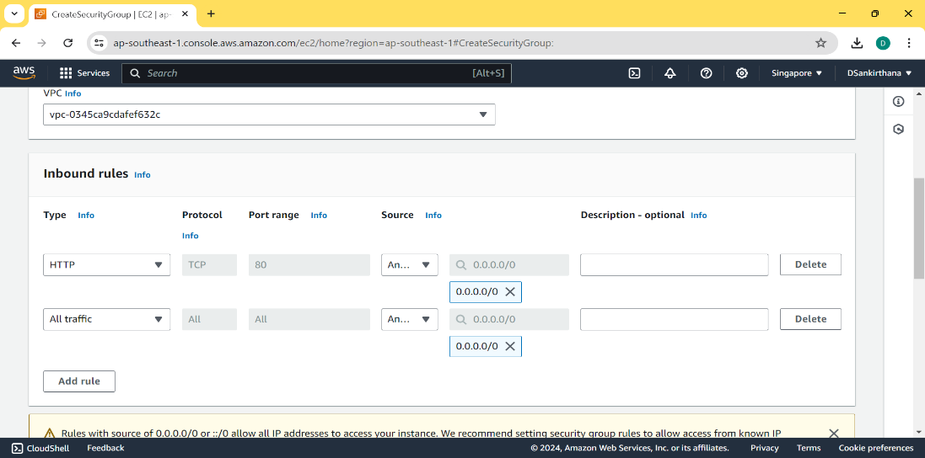
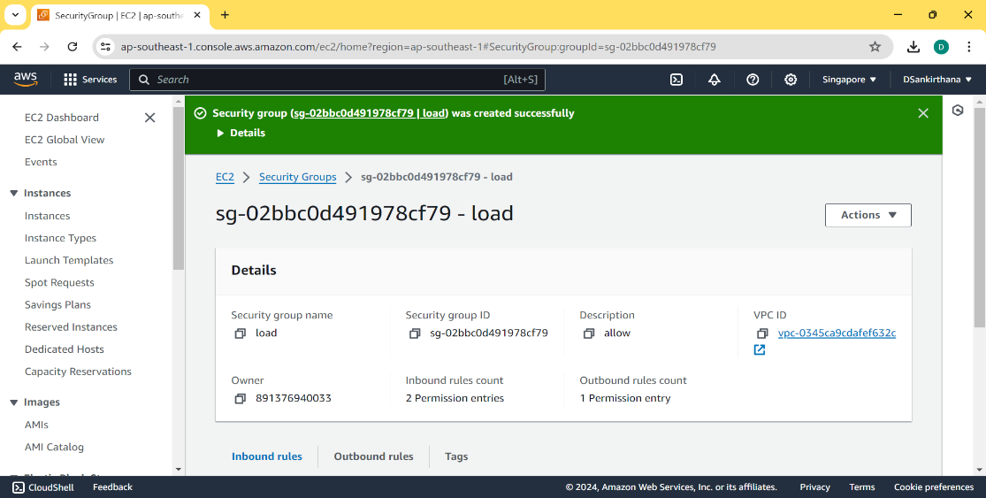
2. CREATE THREE INSTANCES
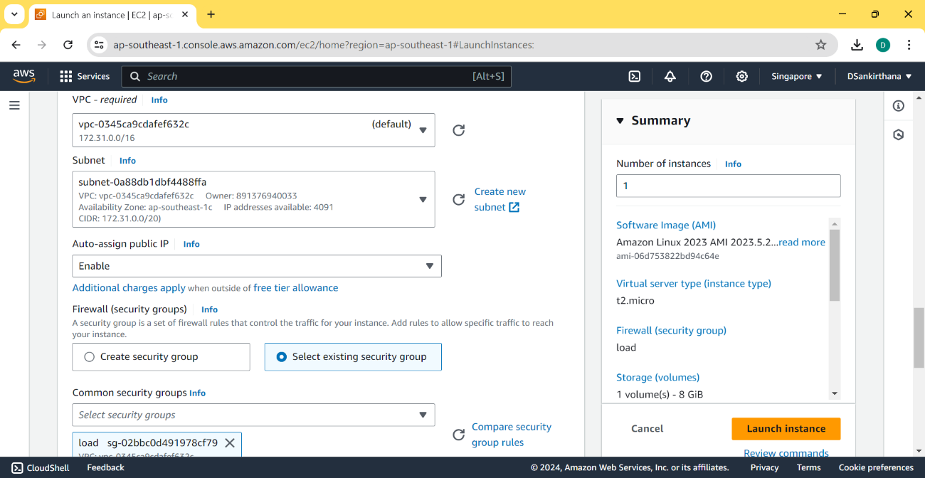
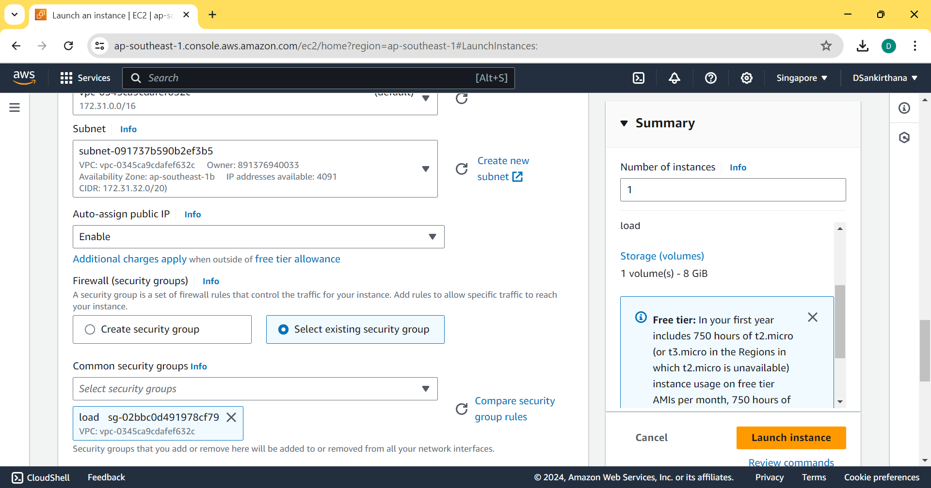
FOLLOW THE ABOVE STEPS FOR ALL THE THREE INSTANCES AND CHOOSE DIFFERENT REGIONS FOR THREE DIFFERENT INSTANCES
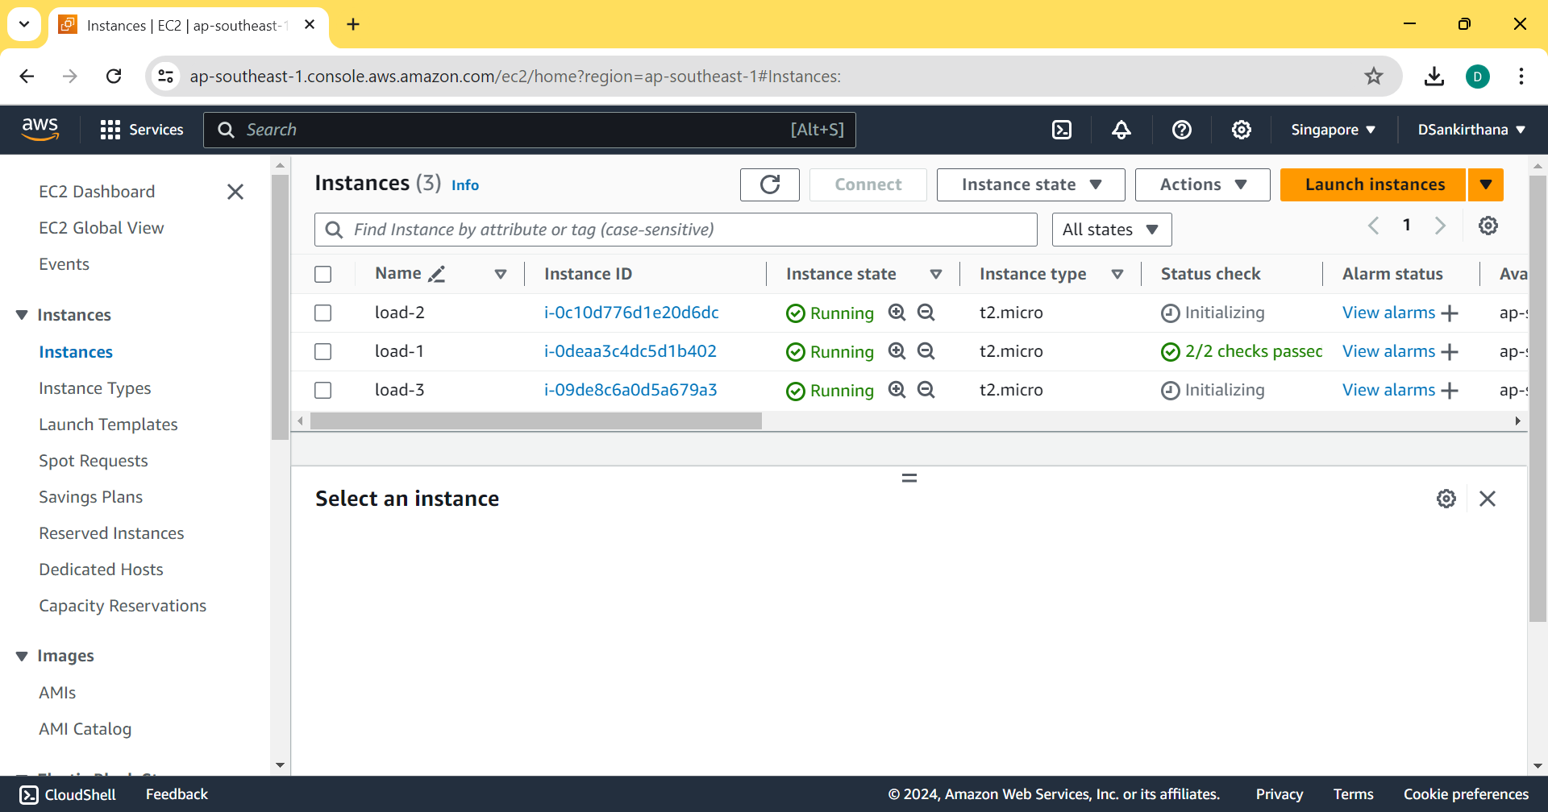
3. TO CONNECT THE INSTANCES, INSTALL NGINX
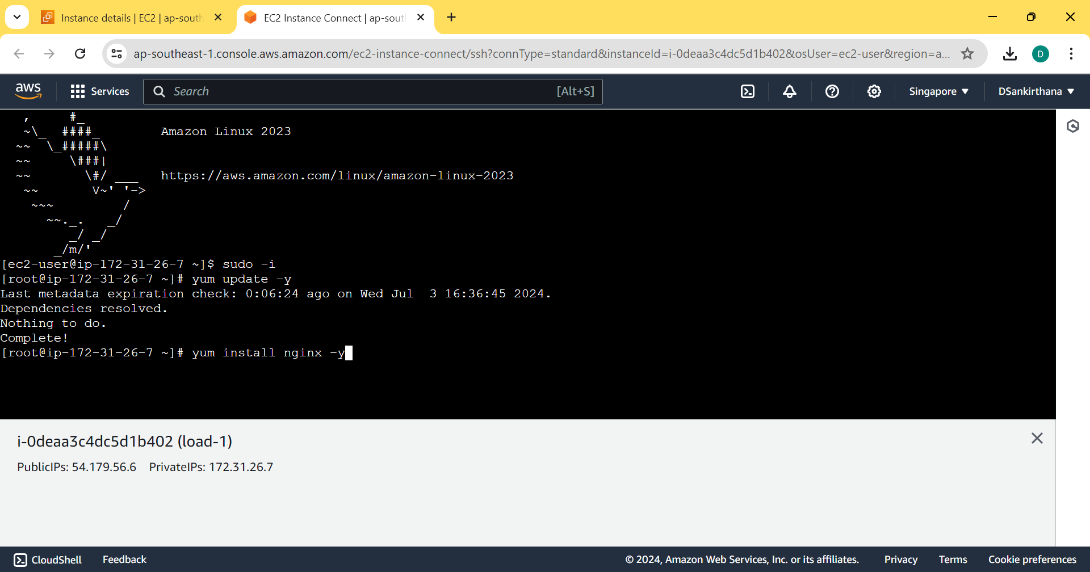
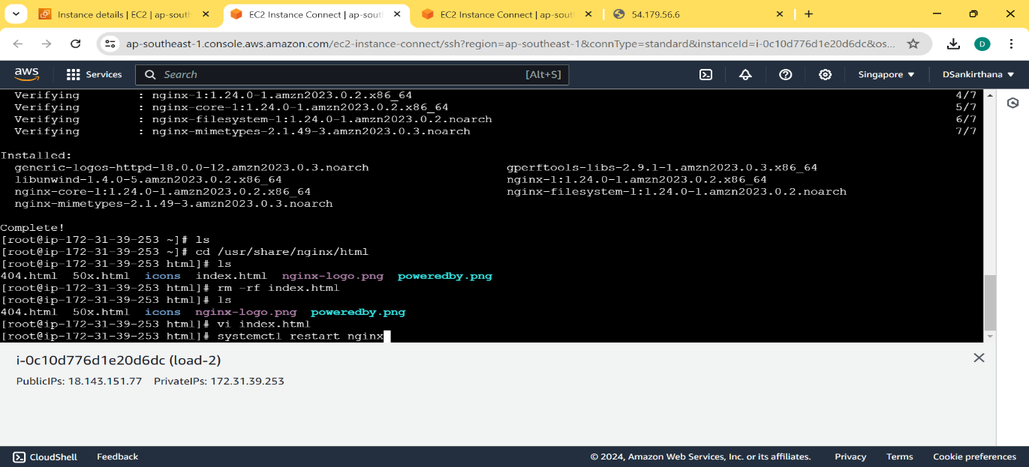
FOLLOW THE SAME PROCEDURE FOR ALL THE THREE INSTANCES INORDER TO INSTALL NGINX
4. CREATE TARGET GROUP
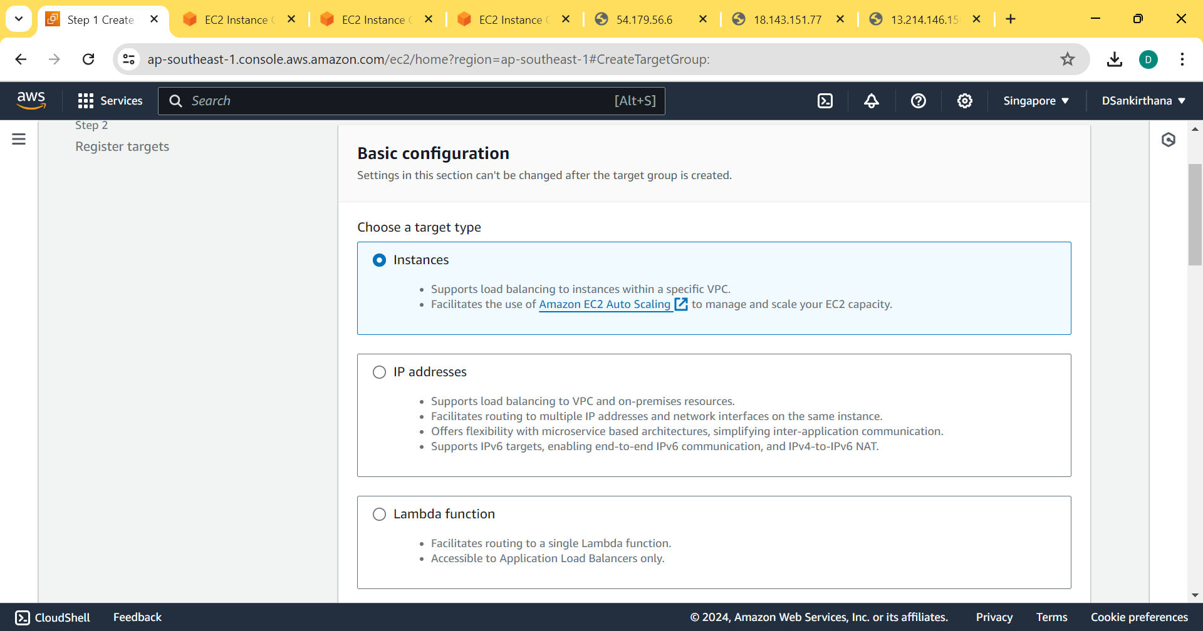
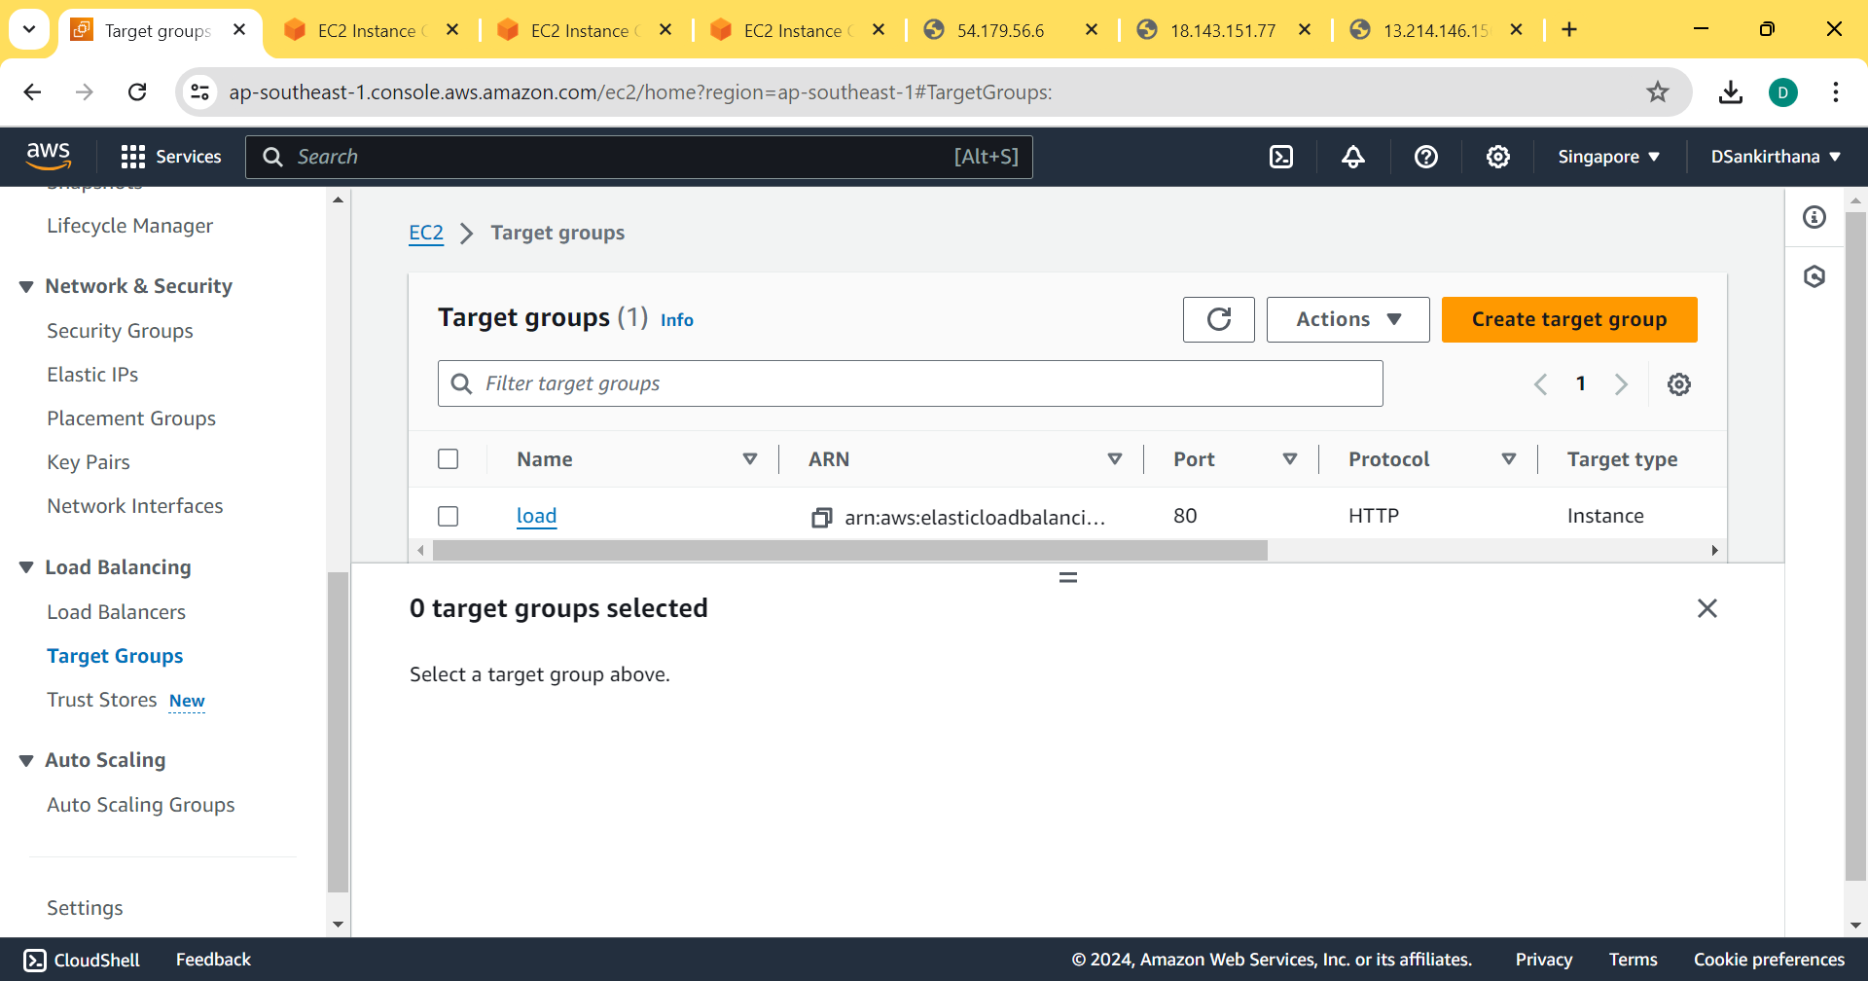
5. CREATE LOAD BALANCER
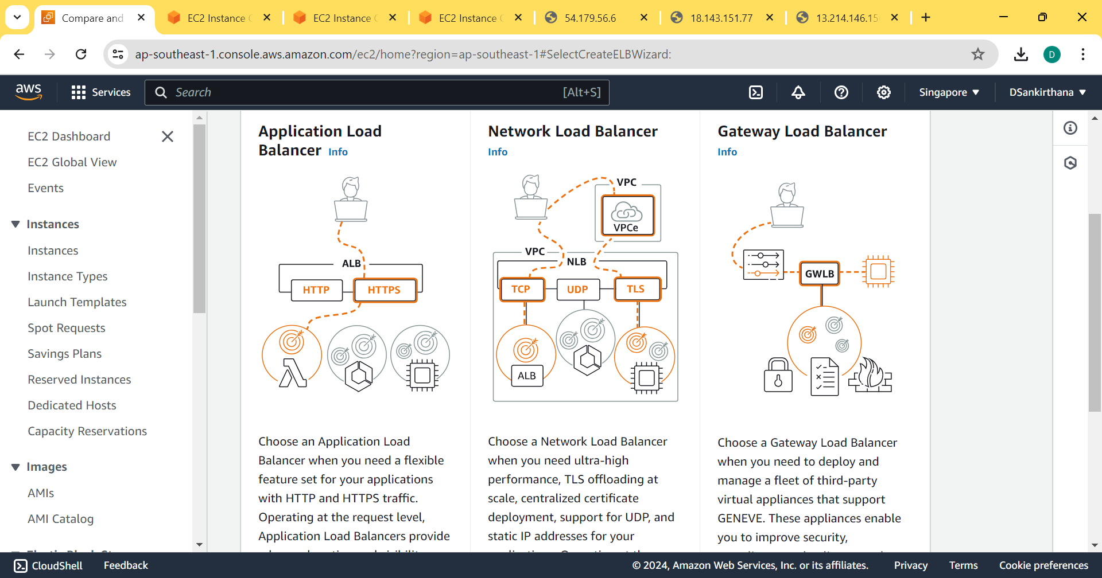
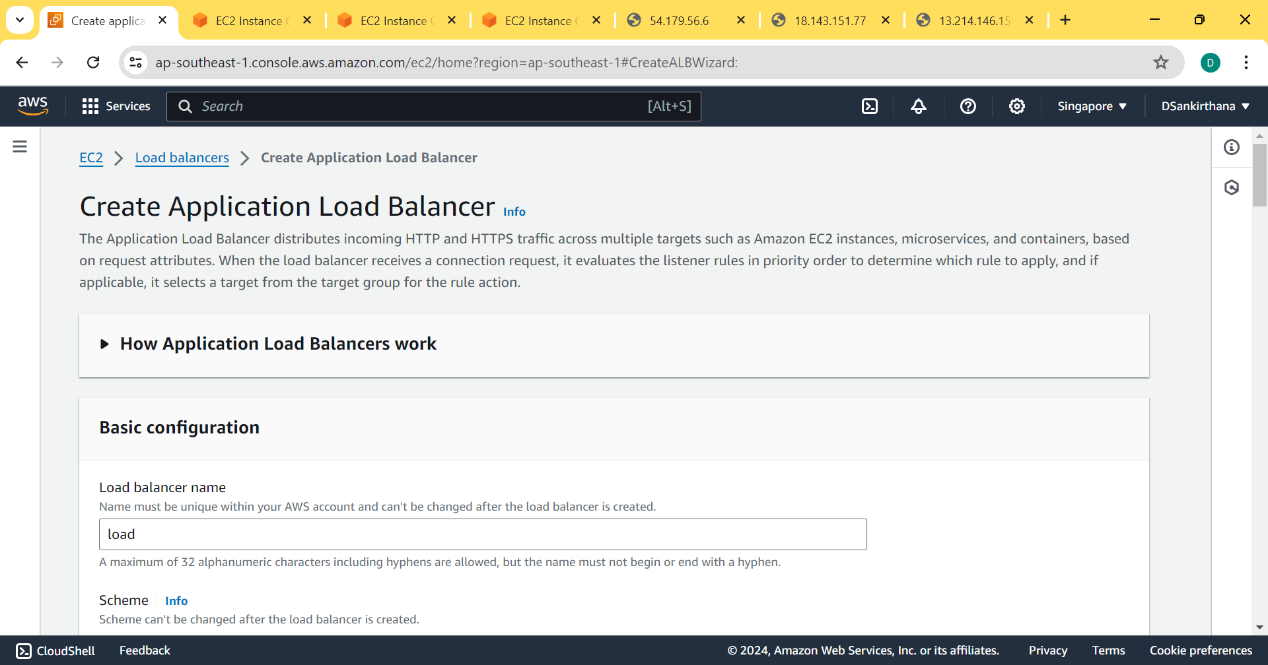
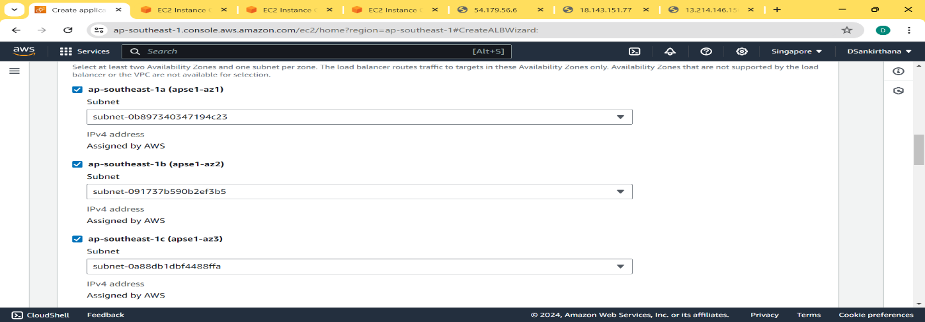
KEEP REFRESHING THE BROWSER AND THE PAGE GETS UPDATED
